Putting One Drive back on your computer

- Click on the file folders
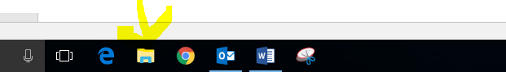
- Put in your school email and click sign in
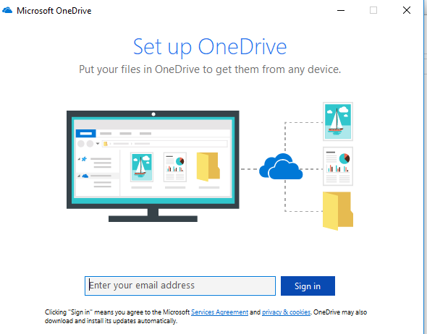
- Click on Work or School
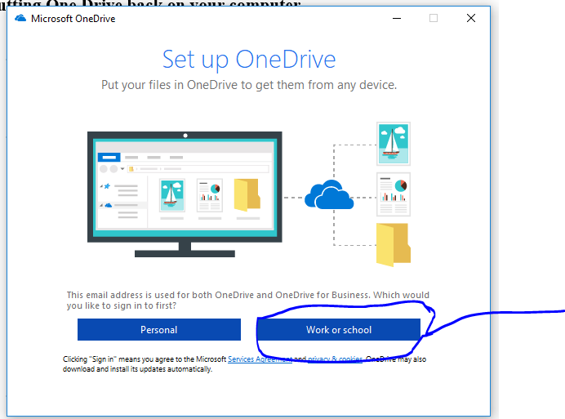
- Put in your username, password, check the box for remember my credentials and then click ok
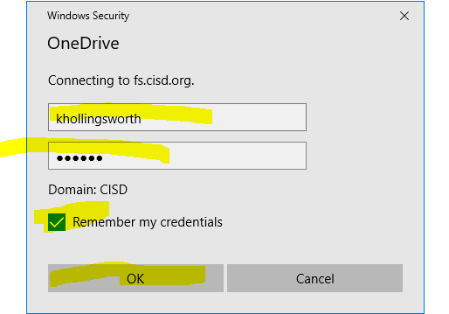

- Click next
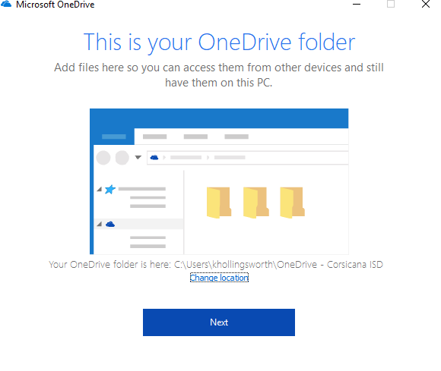

- Click next again
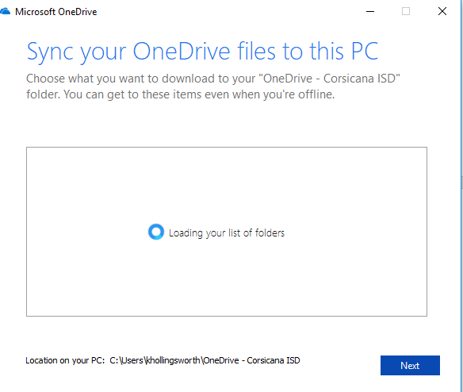
- Click the arrow until it is gone
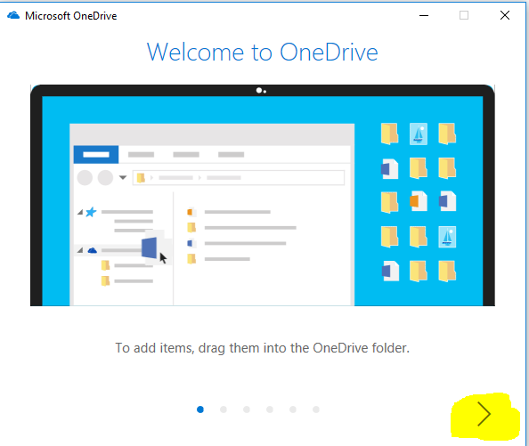

- Click Open my One Drive Folder
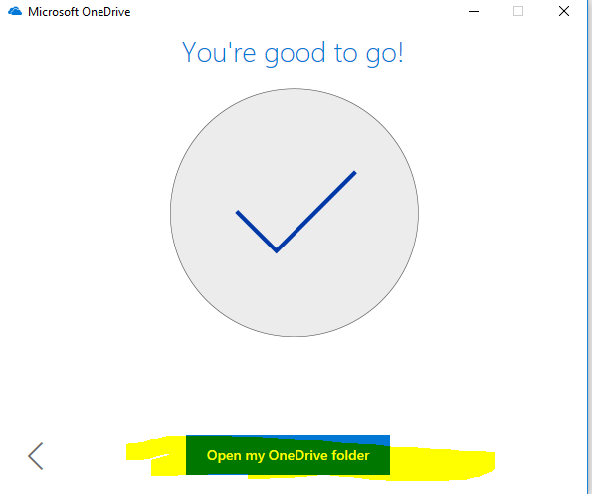

- Then you should be good and it should start syncing your One Drive back onto your computer with all your stuff. Now, just make sure from now on that you choose to save to there when you are saving files and they will always be there.

